**DAILY ONLINE ACTIVITIES SUMMARY**

|  |  |  |  |  |  |  |  |  |
| --- | --- | --- | --- | --- | --- | --- | --- | --- |
| **Date:** | **20-05-2020** | | | | | **Name:** | **Dhanya Bhat** | |
| **Sem & Sec** | **6th A** | | | | | **USN:** | **4AL17CS027** | |
| **Online Test Summary** | | | | | | | | |
| **Subject** | | **System software and compiler design(SSCD)** | | | | | | |
| **Max. Marks** | | **30** | | **Score** | | | **19** | |
| **Certification Course Summary** | | | | | | | | |
| **Course** | **A Full Stack Web Developer – Beginner to Advanced** | | | | | | | |
| **Certificate Provider** | | | **Udemy** | | **Duration** | | | **19.5hrs** |
| **Coding Challenges** | | | | | | | | |
| Problem Statement:   1. Write a simple Python program to implement Diffie–Hellman Key Exchange Example. 2. Write Python Program to Reverse a Given Number This is a Python Program to reverse a given number. Problem Description The program takes a number and reverses it and store it in another variable and show it 3. Python Program to Exchange the Values of Two Numbers using ^ (exclusive or operator). 4. Write a c program to reverse a linked list in a groups of given size.   Test Case 1: If a linked listis: 1 → 2 → 3 → 4 → 5 → 6 → 7 → 8 The value of size k is 2 Then the linked list looks like: 2 → 1 → 4 → 3 → 6 → 5 → 8 → 7  Test Case 2: If a linked listis: 1 → 2 → 3 → 4 → 5 → 6 → 7 → 8 The value of size k is 3 Then the linked list looks like: 3 → 2 → 1 → 6 → 5 → 4 → 8 → 7 | | | | | | | | |
| Status: YES, Completed all Programs | | | | | | | | |
| **Uploaded the report in Github** | | | | | **YES** | | | |
| **If yes Repository name** | | | | | <https://github.com/alvas-education-foundation/Dhanya-bhat-4AL17CS027> | | | |
| **Uploaded the report in slack** | | | | | **YES** | | | |

Online Test Details: (Attach the snapshot and briefly write the report for the same)

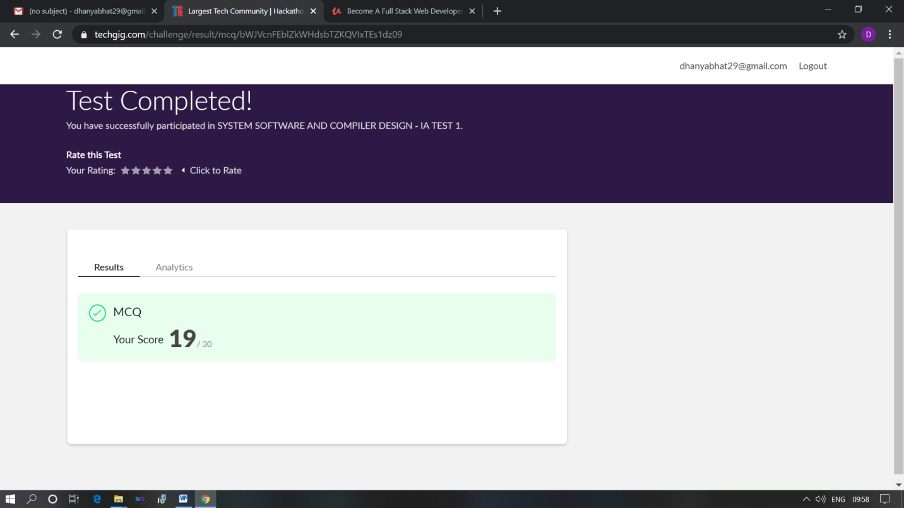

Scored 19 out of 30 in SSCD 1st I.A test

Certification Course Details: (Attach the snapshot and briefly write the report for the same)

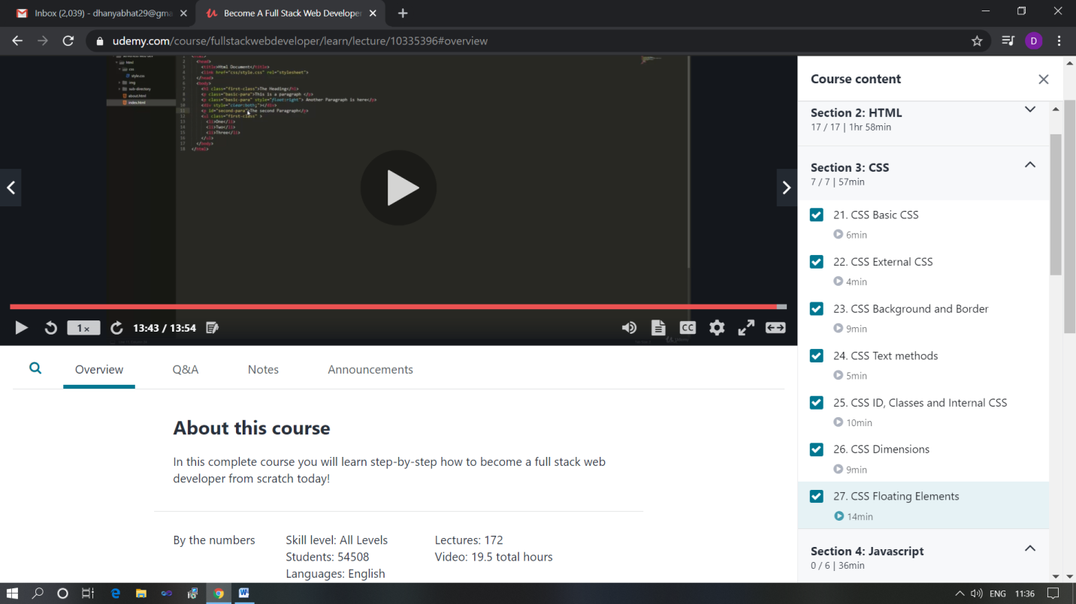

The above course is being taken up by me which is based on the full stack web development. It started with the basics of HTML, Today in Online course I studied about basics of CSS, External CSS, CSS background and border, CSS text methods, CSS ID, classes and Internal CSS, CSS dimensions and also about CSS floating elements.The details of the course and certificate provider is mentioned in the above form.

Coding Challenges Details: (Attach the snapshot and briefly write the report for the same)

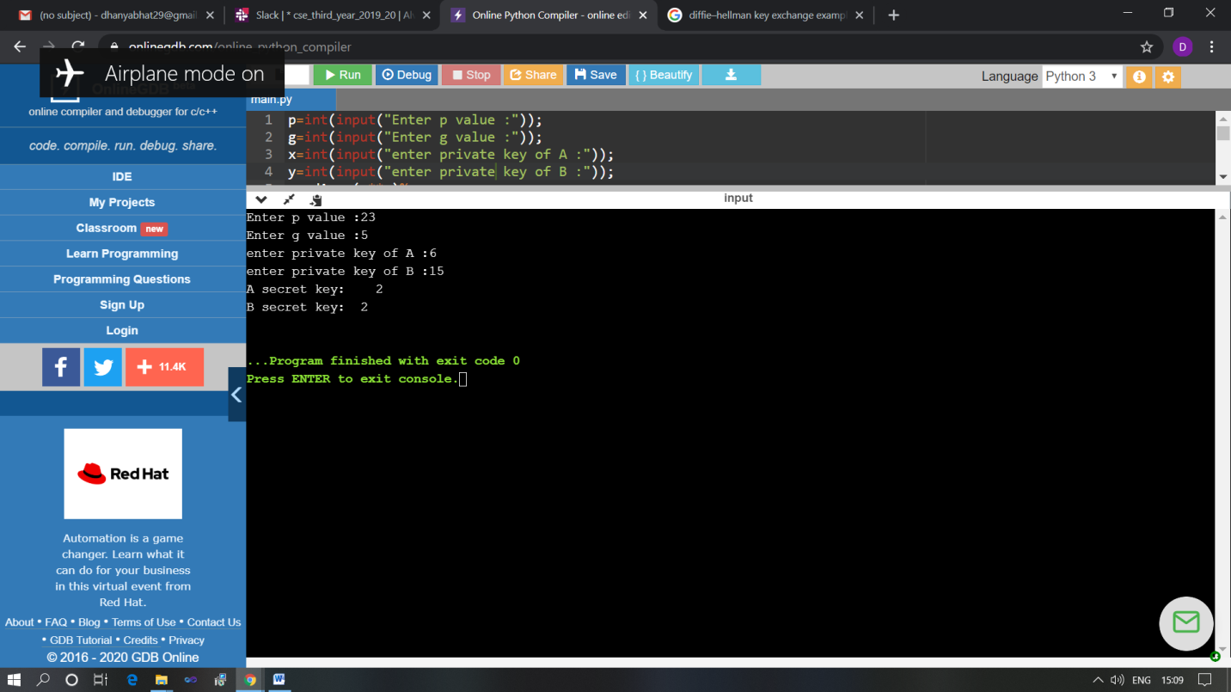

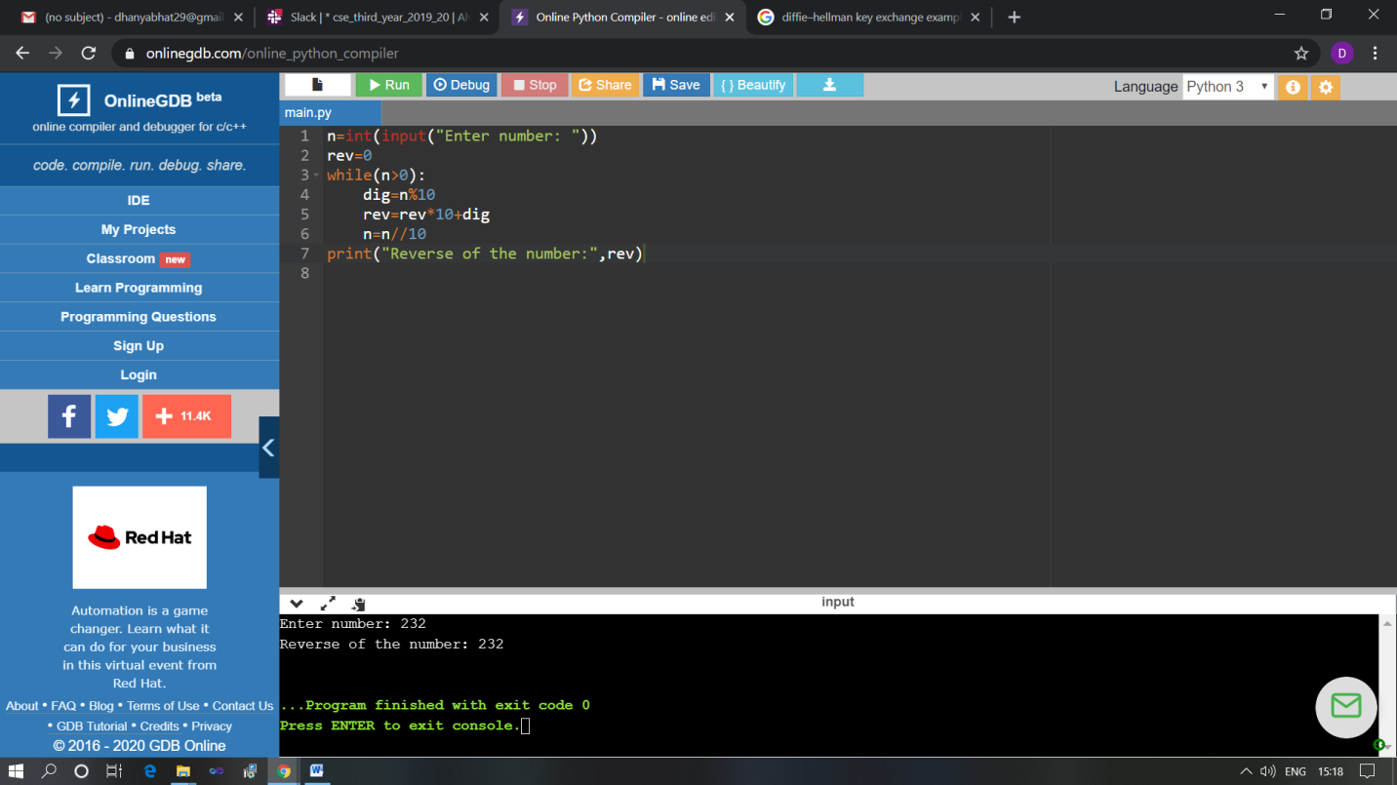

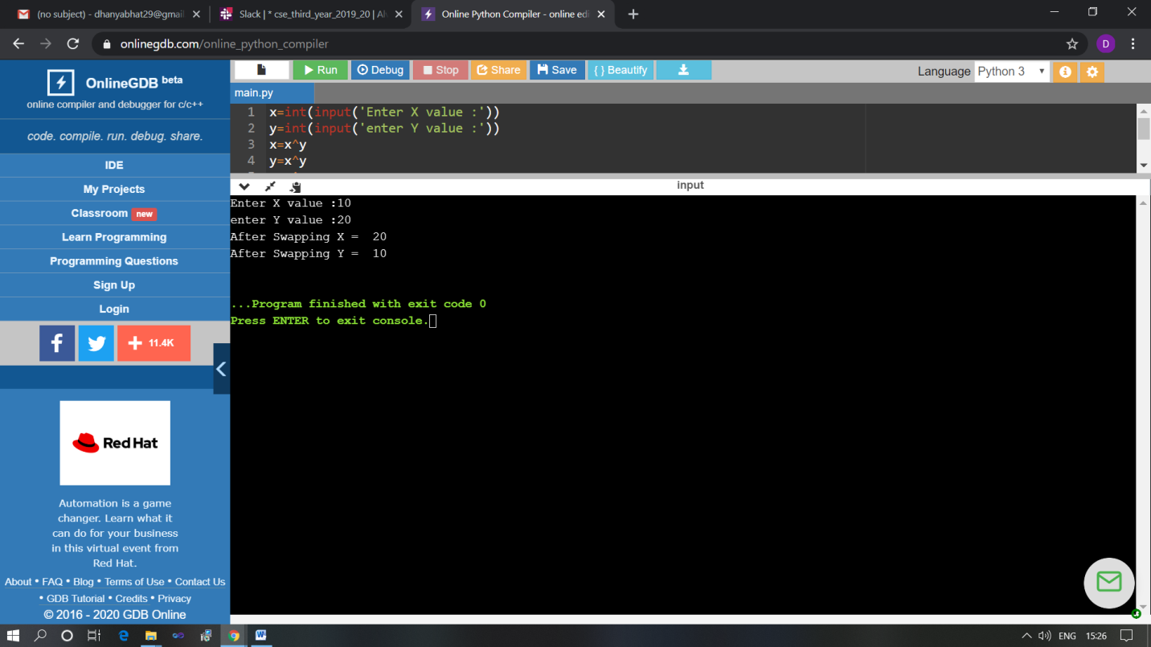

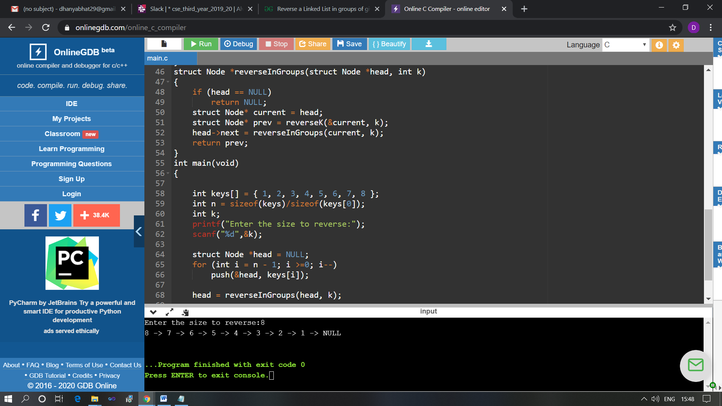

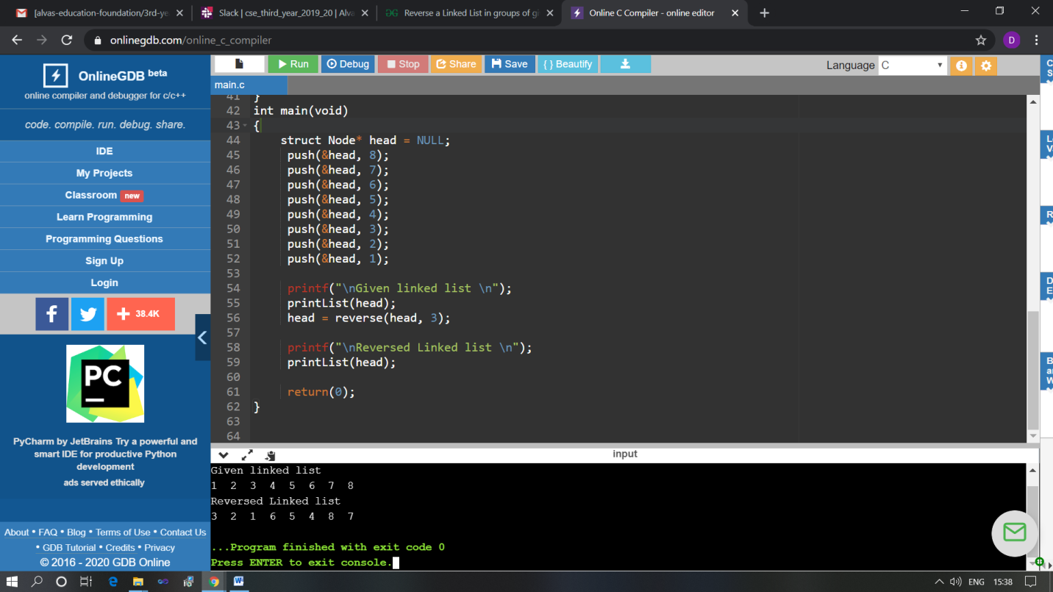

The above Programs were written and executed and the output of the same is displayed above. The code for those 4 programs have been uploaded to the github repository and the link to the same is provided on the form.